PowerFAIDS 2013-2014
Federal Verification document tracking in response to
Dear Colleague Letter GEN-12-11

Preamble:
This document is prepared to assist users of PowerFAIDS in navigating the changing rules for verification beginning with the 2013-2014 year (DCL Gen-12-11). We do not wish suggest that the methods presented are the only solution for document tracking, but believe that it represents a good faith collective effort of five schools to address the Department of Education’s revised requirements.
Throughout this document a familiarity with PowerFAIDS Administration, with the PowerFAIDS Student Module FM-Data forms, Document setup, and Selection set writing is presumed. When in doubt – copy the selection set exactly, and then test the results to validate that you do see the population desired.
In presenting these selection sets and documents we did not attempt to negotiate any difficult use cases – such as Documents required for Disbursement for the entering student population and the contra positive case of documents required for Packaging for returning student population. While it may not be completely trivial to create these cases we believe that are a further expansion of the material presented would confuse our goal of describing the minimum tracking requirements

Reference Material:
Our primary guidance came from the department of education’s 1/18/2013 E-announcement with particular attention paid to Appendix B – a cross reference for which documents are required and under what circumstances those documents are required.
http://ifap.ed.gov/eannouncements/011813VerificationSuggestedText1314.html
As well we referenced the original Dear Colleague letter (DCL-Gen-12-11)
http://ifap.ed.gov/dpcletters/GEN1211.html
Our collective goal was/is – just get it right. This document does not try to go beyond what the Department appears to be requiring and think through a number of corner use cases which may eventually become relevant. Instead we wanted to ensure that we are meeting minimum standards.

PowerFAIDS Documents required:
Dependent Verification Worksheet
Dependent Non-Tax Filers Statement
Dependent SNAP Verification certification
Dependent Child Support Verification Worksheet
2012 Parent IRS Tax Transcript or (2012 Tax Return + Sched X)
2012 Student IRS Tax Transcript or (2012 Tax Return + Sched X)

Independent Verification Worksheet
Independent Non-Tax Filers Statement
Independent SNAP Verification certification
Independent Child Support Verification Worksheet
2012 Student IRS Tax Transcript or (2012 Tax Return + Sched X)

High School Completion Cert (placeholder doc)
Statement of Educational Purpose
Selection Sets (presented in the same order as Appendix B)
Tax Return Filers
Student Case
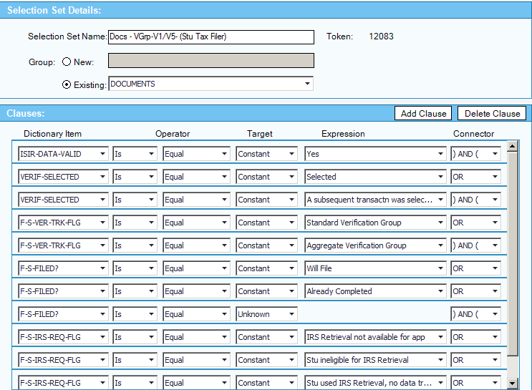
Explanation:
Has a valid ISIR (loaded from a valid source) AND
Is selected for verification AND
Has a Verification Flag of Group V1 or V5 AND
The STUDENT - Did File or Will File or didn’t answer tax filing question AND
Has an IRS match flag indicating that no match is performed or not possible END

This selection set may be associated with the student tax document regardless of dependency status.
Parent Case
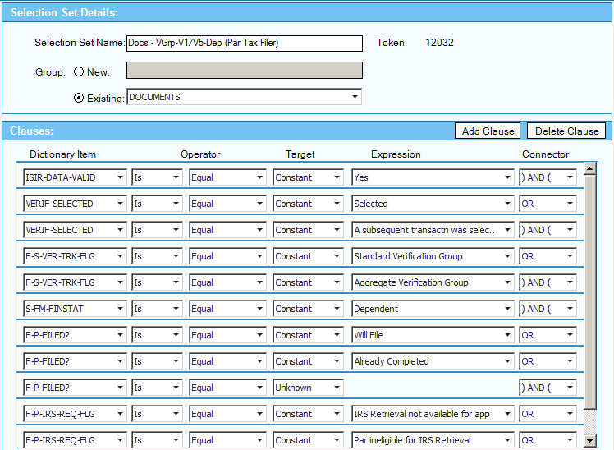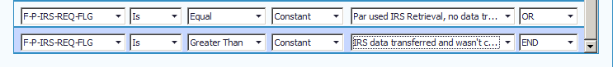

Explanation:
Has a valid ISIR (loaded from a valid source) AND
Is selected for verification AND
Is a dependent record AND
Has a Verification Flag of Group V1 or V5 AND
The PARENT - Did File or Will File or didn’t answer tax filing question AND
Has an IRS match flag indicating that no match is performed or is not possible END

This selection set may be associated with the parent tax document.

Nontax Return Filers
Student Case
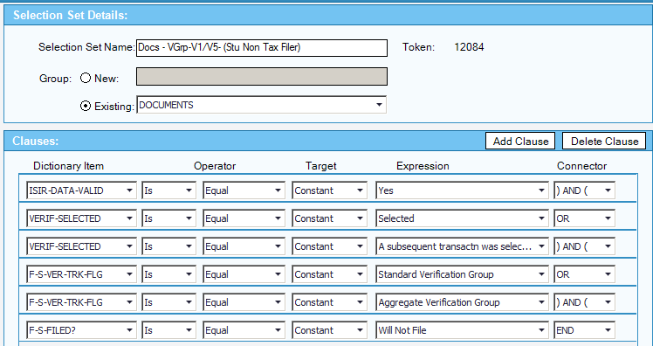

Explanation:
Has a valid ISIR (loaded from a valid source) AND
Is selected for verification AND
Has a Verification Flag of Group V1 or V5 AND
The STUDENT - Will not file END

This selection set may be associated with the student Non-Tax Filer document regardless of dependency status.

Parent Case
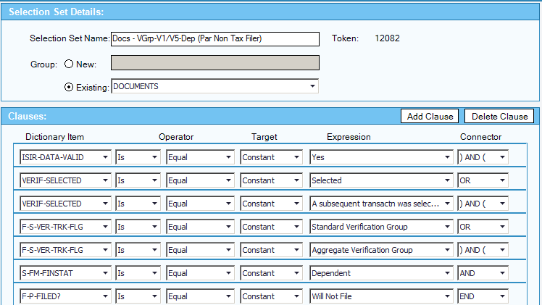

Explanation:
Has a valid ISIR (loaded from a valid source) AND
Is selected for verification AND
Is a dependent record AND
Has a Verification Flag of Group V1 or V5 AND
The PARENT - Will not file END

This selection set may be associated with the parent Non-Tax Filer document.

Household Members
Independent Verification
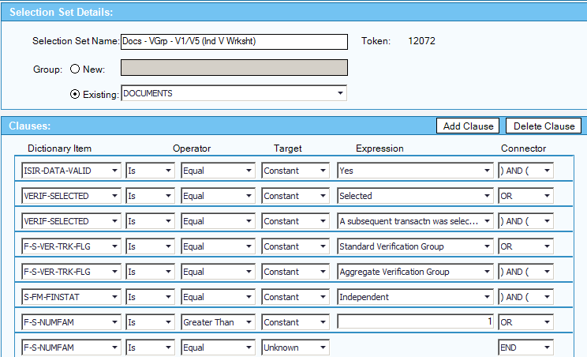

Has a valid ISIR (loaded from a valid source) AND
Is selected for verification AND
Is a independent record AND
Has a Verification Flag of Group V1 or V5 AND
Has a Household size greater than one END**

** There was a great deal of discussion on the last item. Appendix B explains three conditions under which HHS/Num in College do not have to be verified but it was the majority consensus that most of us would verify this information if there were more than one person listed.

It is possible to create a selection set which covers all three cases described in appendix B but this is beyond the limited scope of this document.

The case of no family members listed is included since the needs analysis will presume one, but should be reviewed.

Dependent Verification
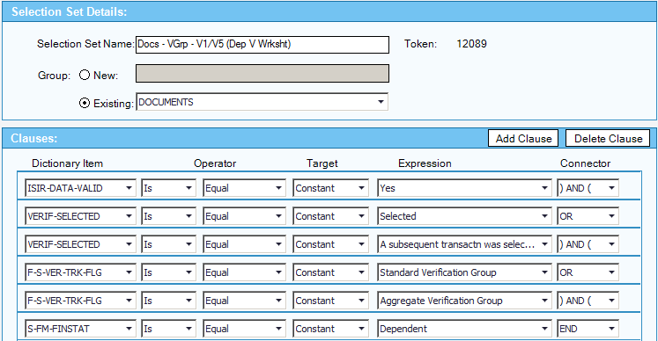

Has a valid ISIR (loaded from a valid source) AND
Is selected for verification AND
Is a dependent record AND
Has a Verification Flag of Group V1 or V5 END**

** As above with the independent verification document criteria it is possible to build the exclusionary cases for three specific situations. However, in the interest of simplicity none are described here.

SNAP and Child Support Paid
Independent Student - SNAP
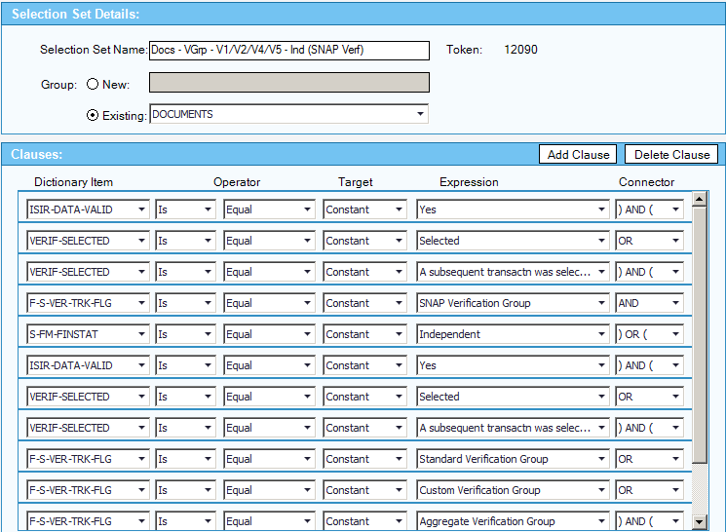
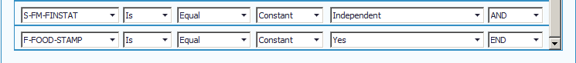

Has a valid ISIR (loaded from a valid source) AND
Is selected for verification AND
Is a independent record AND
Has a Verification Flag of Group V2 END

OR
Has a valid ISIR (loaded from a valid source) AND
Is selected for verification AND
Is a independent record AND
Has a Verification Flag of Group V1, V4, or V5 AND
Has a SNAP/Food Stamp flag of “yes” END**
** The formulation of this selection set and its Dependent contra positive were discussed at length with no firm resolution. The best we could determine from reading the Appendix and other guidance from the department is that they will selectively place some records into category V2 – these must be checked for SNAP. In the other three categories they list if the student has indicated that they are receiving SNAP then SNAP must be verified – so the positive affirmation must also be present.

Dependent Student - SNAP
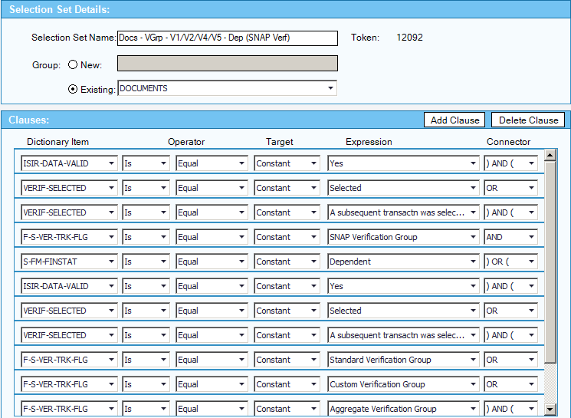
Has a valid ISIR (loaded from a valid source) AND
Is selected for verification AND
Is a Dependent record AND
Has a Verification Flag of Group V2 END

OR
Has a valid ISIR (loaded from a valid source) AND
Is selected for verification AND
Is a dependent record AND
Has a Verification Flag of Group V1, V4, or V5 AND
Has a SNAP/Food Stamp flag of “yes” END**

** Please see the preceding footnote for a general clarification of the development of this set.

Independent Student – Child Support Paid
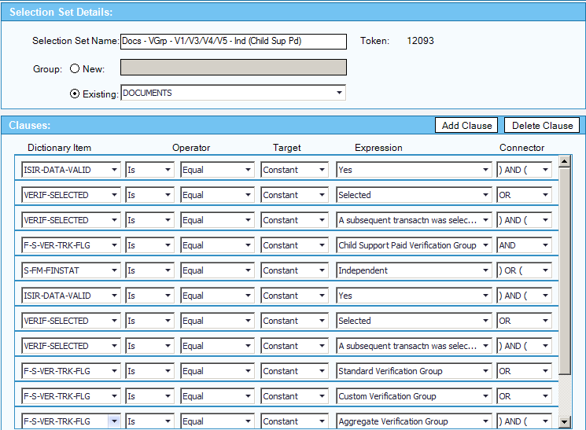
Explaination:

Has a valid ISIR (loaded from a valid source) AND
Is selected for verification AND
Is a independent record AND
Has a Verification Flag of Group V3 END

OR
Has a valid ISIR (loaded from a valid source) AND
Is selected for verification AND
Is a independent record AND
Has a Verification Flag of Group V1, V4, or V5 AND
Has reported Child Support Paid greater than zero END**

** The formulation of this selection set and its Dependent contra positive were discussed at length with no firm resolution. Like the SNAP selection sets this was contentious and depends in great measure on reading the context to find the intent. Our best read is that if the record is flag V3 then Child Support paid must be verified, in the other three cases it only must be verified if the student reported paying Child Support.

Dependent Student – Child Support Paid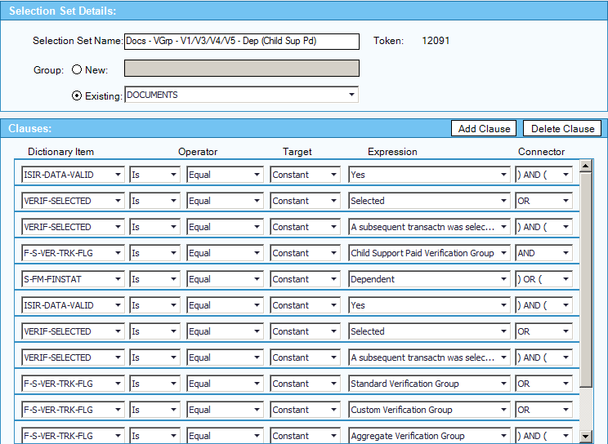
Explaination:

Has a valid ISIR (loaded from a valid source) AND
Is selected for verification AND
Is a dependent record AND
Has a Verification Flag of Group V3 END

OR
Has a valid ISIR (loaded from a valid source) AND
Is selected for verification AND
Is a dependent record AND
Has a Verification Flag of Group V1, V4, or V5 AND
Has reported Child Support Paid greater than zero END**

** Please see the preceding footnote for a general clarification of the development of this set.

High School Completion, Identity, and Statement of Educational Purpose
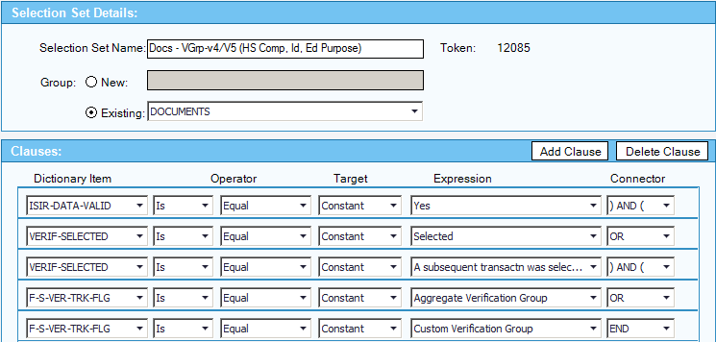
Explanation:

Has a valid ISIR (loaded from a valid source) AND
Is selected for verification AND
Is a dependent record AND
Has a Verification Flag of Group V4 or V5 END**

** This is probably the most straight forward selection set. However, there was a severe amount of consternation for two readers who kept asking in several ways “but how does the department decide?”. Another participant in this process contacted a colleague at the department who essentially shared that these cases are currently “randomly selected” based upon department criteria. The emphasis here was that we could not use the information present on the ISIR to garner any sense as to the “Fact of Graduation” and that the school must collect documentation.

One further thought – for most participating schools the collection of HS Diploma is not the function of the Financial Aid Office. Thus while this document should be tracked as a requirement – the business process to satisfy this requirement may actually involve the communication and

